# CS 255 System Design Document

## UML Diagrams

### UML Use Case Diagram

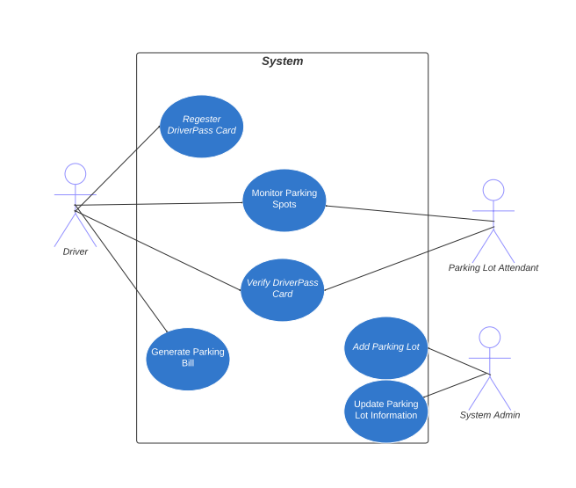

### UML Activity Diagrams

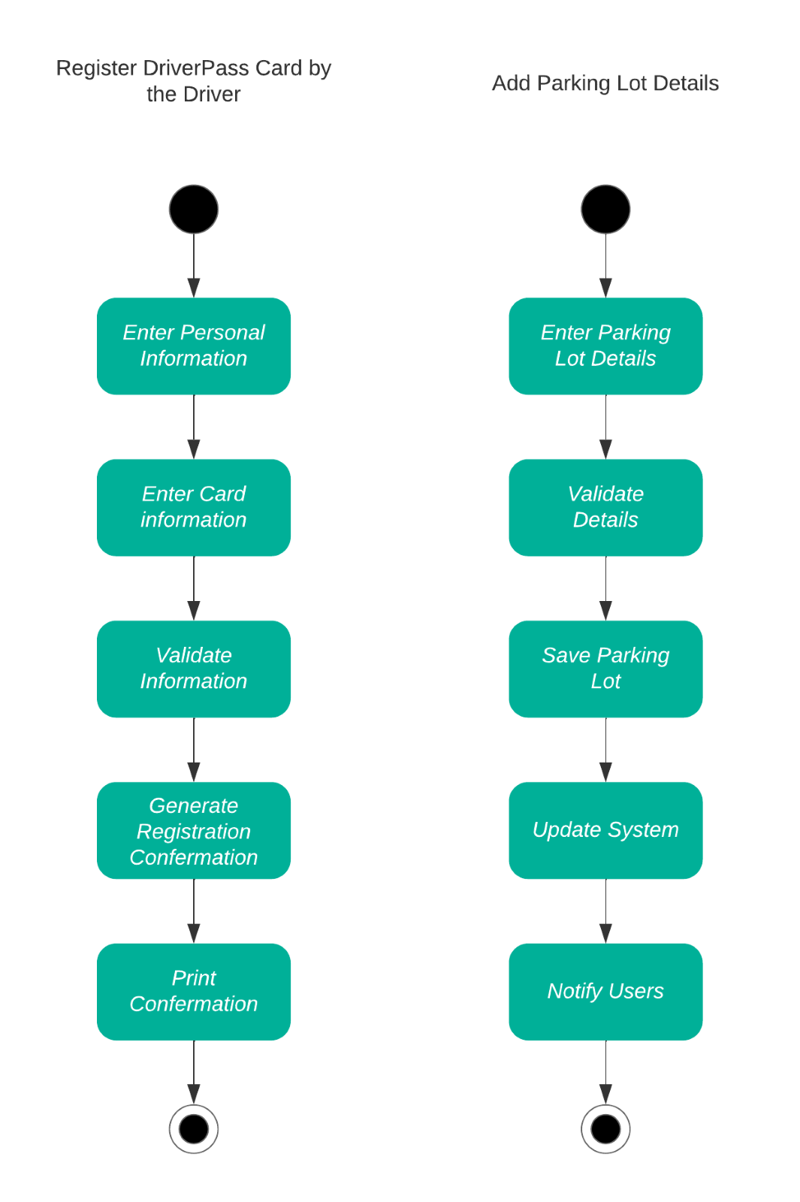

### UML Sequence Diagram

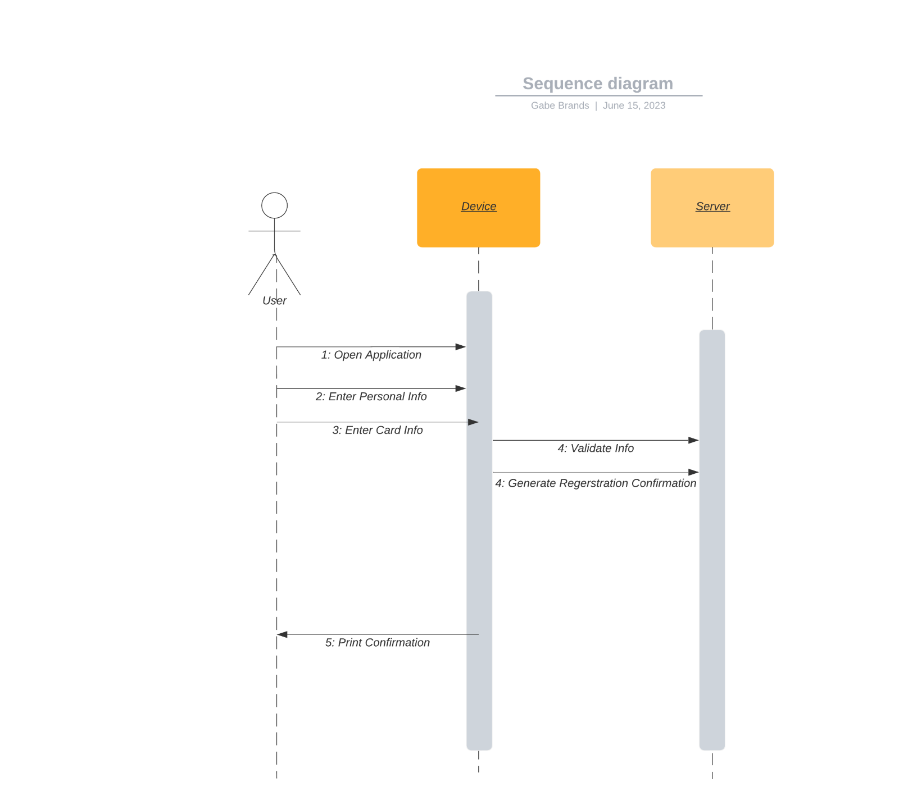

### UML Class Diagram

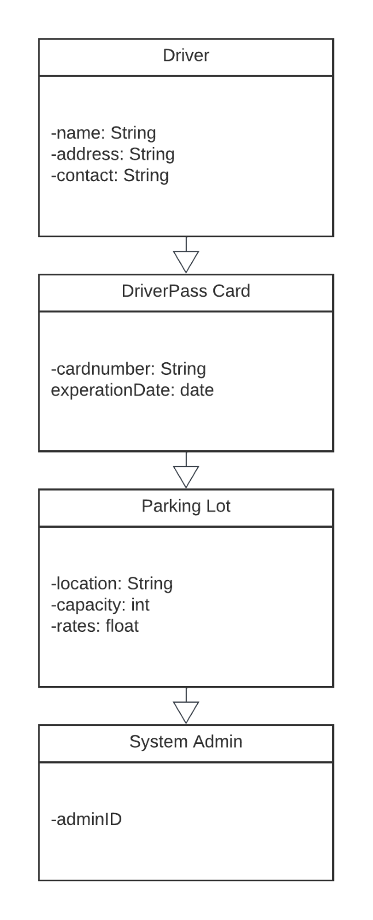

## Technical Requirements

1.Performance Requirements: The system should be designed to provide fast response times for user interactions. It should be able to handle multiple concurrent users without significant performance degradation. Response time for generating reports should be within acceptable limits.

2.Platform Constraints: The system should be accessible through web browsers and mobile devices. It should be compatible with popular operating systems such as Windows, macOS, iOS, and Android. The system may require a back-end database to support data storage and retrieval.

3.Accuracy and Precision: User identification and input should be accurately recorded and displayed. Numeric calculations, such as test scores, should be precise and consistent.

4.Adaptability: The system should be easily adaptable to future changes in DMV rules, policies, and sample questions. It should support the addition or removal of driving lesson packages with minimal technical effort.

5.Security: User authentication should be implemented, requiring credentials to log in. The system should ensure secure connections and data exchange between the client and the server. Measures should be in place to protect against "brute force" hacking attempts.

Password recovery mechanisms should be available for users who forget their passwords. User data, including personal and financial information, should be securely stored and transmitted.

6.User Interface: The system should provide an intuitive and user-friendly interface for easy navigation. Users should be able to view their progress, including completed and ongoing tests, with relevant details. Online scheduling, modification, and cancellation of driving lesson reservations should be supported. Users should have a means to contact DriverPass through the system and receive timely responses.